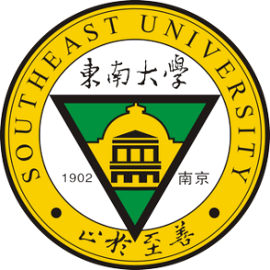
Southeast Symposium of
Recent Developments in Geotechnics
7th – 9th July 2019
GEO Symposium
Southeast University, Nanjing, Jiangsu, P.R. China

Participation form
(To be returned by 25th May 2019 by emailing to geo@pub.seu.edu.cn)

Title: Dr. / Ing. / Prof. / Mr. / Ms. (please delete as appropriate)
Surname:
First Name:
Academic position：
Organisation:
Contact address & number:
Email address:
Scheduled date of arrival:
Scheduled date of departure:
Q1, Would you like to give a presentation?
YES / NO
If yes, please provide the title of your presentation:

Q2, Are you interested in recruitment opportunity at Southeast University?
YES / NO
If yes, please provide your CV, including but not limited to details on your educational and professional background, research interest, list of publications, markers of esteem, and any other relevant information

Q3, Would you like to apply the travel grant?
YES / NO
If yes, please provide your CV, details of the proposed presentation, your research expertise and background, how you can contribute to and benefit from the event, and any other relevant information

Q4, Do you have special diet requirement?
YES / NO
If yes, please provide details:

Q5, Please use this space to give any other relevant information

Printed Name:
Signature:

Date:

