Asia Steel Bridge Competition

2017

Rules

1. Changes of rules from 2016 1

2. Design conditions 2

2.1 Dimensions and design conditions 2

2.2 Bridge type 3

2.3 Dimensional regulation to carry loading plates 3

2.4 Size and Weight of one bridge member 4

2.5 Bridge member 4

2.6 Fastener 4

2.7 Member-to-member connection 5

2.8 Construction site 5

2.9 Vehicle running space 6

2.10 Loading plates 6

3. Measurement items 6

3.1 Size of a bridge member 6

3.2 Construction time 6

3.3 Number of constructors 6

3.3 Bridge weight 6

3.4 Deflection 7

3.5 Clearance 7

3.6 Vehicle running space 7

4. Scoring categories and Awards 7

4.1 Construction Costs $CC$ 8

4.2 Structural Costs $CS$ 8

4.3 Aesthetics ($D$) 8

4.4 Presentation ($P$) 8

4.5 Prediction of deflection ($Pr$) 8

4.6 Overall performance 9

5. Construction 9

5.1 Definition 9

5.2. Tools 10

5-2-1. Fastener tools 10

5-2-2. Pouch 10

5-2-3. A chain block, a temporary bridge member 10

5.3. Preparation 10

5.4. Carriage 10

5.5. Assembly 10

5.6. Finish 11

5.7. Repairs 11

6. Exhibition and voting 11

7. Presentation 12

8. Loading test 12

8.1 Loading weight 12

8.2 Loading test and deflection 12

9. Examination 14

10. Penalties 15

10.1 Limitation of a bridge member 15

10.2 Limitation of construction time 15

10.3 Assembly works outside of the staging yard 15

10.4 Construction works outside of the construction site 15

10.5 Clearance 15

10.6 Floor beams 16

10.7 Space to install loading plate 16

10.8 Bridge length 16

10.9 Gloves, Helmet, and Goggles 16

10.10 Others 16

10.11 Penalty table 16

# 1. Changes of rules from 2016

The following items identify some of major changes from the 2016 rules.

1. Increase 50 kgf loadings at center of bridge. 200 kgf weight is given to the center span and another 150 kgf is given to the quarter point of the span. (Section 8.1, page 12)

# 2. Design conditions

## 2.1 Dimensions and design conditions

* The bridge length is between 4000mm and 4400mm, and its span is 4000mm
* The bridge is settled on the four abutments (**Fig.2.5**). The clearance must be over 100mm.
* When load tests, two loading plates is placed at the center of the span and a quarter of the span. Bridges must have the space for the loading plate of 600mm x 600mm.(**Fig.2.1**,**2.2**) See also **2.3**
* Loading weight of 200 kgf is given to the span center and another 150kgf to the quarter point of the span on the loading plates. The bridge must be able to safely carry the loadings that are in total 350 kg.
* The span center deflection in the full loading condition is targeted at 6mm ($±1mm$). If the average deflection value reaches 15mm, the bridge is regarded as collapse.

**Fig.2.1** Bridge dimensions(Plane view)

Plane view

(deck bridges)

Side view

*C*

*L*

4000～4400mm (bridge length)

600mm

(Maximum space between the outer edge of the main structures)

Loading plate

*C*

*L*

Plane view

(halfthrough orthrough bridges)

*C*

*L*

600mm

(Minimum space between the inter edges of the main structure)

Loading plate

Loading plate

1000mm

Loading plate

Loading plate

(Plane view)

**Fig.2.2** Loading plate andｓ sectional dimensions



unit：mm

The cross section of deck bridges

Main girder (Main structure)

Pier

<600

Outer edge

max 600

Loading plate

*C*

*L*

The cross section of half through or through bridges

Inter edge

Loading plate

*C*

*L*

>600

Main girder (Main structure)

）

Floor beam

Pier

## 2.2 Bridge type

Any bridge type is OK, as long as it is a simply-supported bridge.

Piers are prepared by the host university; while participants fabricate and assemble their upper structures.

Dimensions of the pier are shown in **Fig.2.3**. Participants must consider their bridges being placed on the prepared piers.

**Fig.2.3** Pier



100～

150

100~

150

250

300( at least)

100~

150

100~

150

bridge

unit：mm

## 2.3 Dimensional regulation to carry loading plates

Bridges must have a $600mm×600mm$-space to put a loading plate at the bridge center and the quarter point of the span.

* Deck bridges

The space between outer edges of main girders must be smaller than 600mm because two loading plates, the width of which is 600mm, are placed on the top face as shown in **Fig.2.4(a)**.

* Through bridges and half through bridges

Through bridges and half through bridges, for example “through truss bridge”, ”through arch bridge”, “Vierendeel bridge”, must have two or more floor beams in each loading area. In order to place loading plates, the distance between inner edges of main structure must be over 600mm **Fig.2.4(b)**.

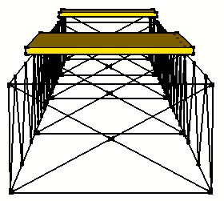

(a) Deck bridge (b) Through bridge

**Fig.2.4** Floor beams

## 2.4Size and Weight of one bridge member

Straight steel or curved steel may be used for bridge members.

The size of one bridge member must be less than 150mm x 150mm x 800mm. The size is checked by a 150mm x 150mm x 800mm-volumn box (**Fig.2.5**). One steel assembly connected by bolts is regarded as one bridge member, if it can be put into the box. The size will be checked before the construction work on the competition day. One bridge member must be equal to or less than 10kg.

**Fig.2.5** Regulation of a member size



150

unit: mm

150

800

size-check box

Sectional view

A member must be put into the size-check box

bridge member

## 2.5Bridge member

1. Participants must use rigid steels; that is, a cable or a wire is not allowed.
2. Bridges must consist of structural steel. The steel is defined as an iron alloy that is strongly attracted to the magnet.
3. The size of a bridge member must be less than $150mm×150mm×800mm$. It means that one bridge member can be put in the box of $150mm×150mm×800mm volumn.$ (see also2.3)
4. A bridge member must be a rigid component during the construction and the loading tests. Hinged, telescoping members are prohibited. This prohibition includes members with parts that are intended to slide, rotate, deflect or bend relative to the member such as cams, sliding pins, springs, and snap-lock devices.
5. A member may consist of multiple parts rigidly joined together before timed construction begins. Those parts must remain rigidly joined throughout timed construction and in the completed bridge. If the bridge has ready-component bolts and nuts, it cannot be loosened throughout the timed construction, and those bolts and nuts must be colored to show that they are not fasteners.

## 2.6Fastener

1. A fastener is a steel bolt that is not a part of a member, with at least one steel nut that is not part of a member. Diameter is not restricted.
2. The nuts in a fastener must match the bolt.
3. Nuts and bolts that connect the parts of a member but do not connect a member to other members are not considered to be fasteners.
4. Fasteners must NOT be colored. The original metallic surface condition must be kept in order to distinguish fasteners from a part of the member.
5. Washer is allowed to use as a part of fasteners; also, as a use of a spacer.
6. If participants use washers, the washers must not be welded or glued to the bolt head or the nut.
7. Tools for fasteners must be hand worked, not be electric assists including battery devices. Those tools, which are spanner, ratchet, and monkey wrench for example, must be prepared by participants themselves.

## 2.7Member-to-member connection

1. During the construction works, each member must be connected by at least one fastener.
2. A couple of a bolt and a nut must match each other on its size.
3. A member shall be connected to other ones by combinations of bolts and nuts during timed construction. No bolts and nuts can be welded to members; also screwed connections are not allowed (**Fig.2.5**)





Bolt

Nut

Welding

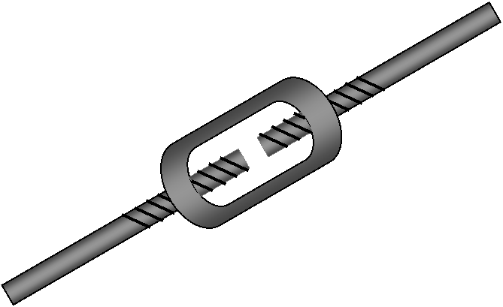

**Fig.2.5**ProhibitedConnections

## 2.8 Construction site

1. Bridges cross over a 1600mm-wideriver. The river is located right below the span center (**Fig.2.6**).
2. The river in the construction site is represented by tape.
3. Both sides of the river are river bed. Constructors can work in the river bed (**Fig.2.6**).
4. If a constructor touches the river or drops a bridge member, fastener or tools to the river or ground, penalties will be given.



**Fig.2.6**Construction site (same as 2014)

## 2.9 Vehicle running space

B*H*L=500*300*4000~4400

Bridges provide vehicle running space of 500mm width, 300mm height through the bridge. For through bridges, the portal bracings HPB must be located over 300mm to allow the vehicle passage (**Fig. 2.7**). For the open deck bridges, it is assumed that vehicles run on the top surface; hence, it is no necessary to consider HPB (**Fig.2.7**). The space does not include loading plates.



Hmax is NOT limited

4000~4400

**Fig.2.7** Dimensions of vehicle running space

## 2.10 Loading plates

Participants are not required to prepare loading plates. The plates are prepared by the host university.

# 3. Measurement items

## 3.1 Size of a bridge member

Large bridge members must be checked by the check box, the volume of which is $150mm×150mm×800mm$ (**Fig.2.5**). If a bridge member cannot put in the box, a penalty will be given.

## 3.2 Construction time

Judges measure the construction time and repairing time with a stop watch. The construction time in scoring is a summation of construction time and 150% of repairing time (See also 5.7). The number of repairing constructors must be the same as the construction stage.

## 3.3 Number of constructors

Less constructors would be an advantage in the score; however, the construction works might be forcibly stopped if the safety was not paid attention to. The maximum number of constructors is limited to 6.

## 3.3 Bridge weight

Bridge weight is recorded by using four weight scales (**Fig.3.1**). A summation of the four scales is recorded for scoring. Weight penalty is added to the weight if the size regulation of a bridge member is violated.

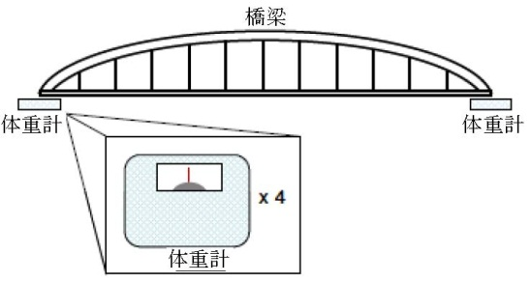

**Fig.3.1** Weight measurement

bridge

weight scale

weight scale

weight scale

Loading plates, construction tools, piers and posters are not included in the bridge weight.

## 3.4 Deflection

Deflection is measured at the span center. The deflection is recorded at 30 seconds after all the weight loads are applied. Deflection value is recorded by the average of two records in the transverse direction.

## 3.5 Clearance

Clearance is checked by measuring the distance from the ground to the lowest part of the bridge. (**Fig.3.3**)



**Fig. 3.3** Clearance check

## 3.6Vehicle running space

Judges check whether the bridge provides vehicle running space. A plate of 300mm*500mm passes the whole bridge for the check.

# 4. Scoring categories and Awards

Scoring is done in the following 6 categories and one overall performance.

1. Construction cost($C_{C}$)
2. Structural cost($C_{S}$)
3. Total cost($C_{C}+C_{S}$)
4. Aesthetics $\left(D\right)$
5. Presentation $\left(P\right)$
6. Prediction of deflection $\left(Pr\right)$
7. Overall performance

The award of each category is given to the top two teams.

## 4.1 Construction Costs $\left(C_{C}\right)$

The winner is the team which recorded the lowest cost. The construction costs $C_{C}$ follow the next formula.

$Cc\left(THB\right)$ =[Number of constructors]*[Total construction time(min)]*5 $\left(×{1000}^{3}\right)$

Total construction is a summation of construction time, repairing time multiplied by 1.5 (see also 3.2) and time penalties. The time penalties are from drops of tools, fasteners, bridge members, to step into the river (See also Chap.10).

## 4.2 Structural Costs $\left(C_{S}\right)$

The structural cost is calculated by the following formula. The team of lowest cost wins in this category.

$C_{S}\left(THB\right)$ =[bridge weight] $5\left(×{1000}^{3}\right)+δ×100\left(×{1000}^{3}\right)$

*

Where, $δ$ is determined by deflection at the span center.

If 5mm< [deflection at the span center] < 7mm,

$$δ=0$$

Else if, ([deflection at the span center] $≦5mm$, or $7mm≦$ [deflection at the span center])

$$δ=\left|(\left[deflection at the span center\right]-6mm\right|\left(Absolute value\right)$$

Else if bridge collapses before all load is applied (i.e. deflection > 15 mm),

$$δ=10$$

The bridge weight includes the bridge’s own weight, and weight penalties. (Chap.10)

## 4.3 Aesthetics ($D$)

Aesthetics is scored by voting from committee members and team members. Each team votes 1 ballot paper and cannot vote own team. One team name is written in the one ballot paper. Voters must consider structural reasonability, proportion, grace, well-finished details and color arrangements.

## 4.4 Presentation ($P$)

Evaluation details follow Chap.7

## 4.5 Prediction of deflection ($Pr$)

All the teams must predict their deflection (mm) before the loading. The deflection value is taken at the span center, and average of two deflection values of the both sides.

Difference is defined by the following equation.

$$Diff=\left|\left[Predected deflection\right]-\left[Actural deflection\right]\right| (absolute value)$$

The point is scored by the following table

|  |  |
| --- | --- |
| **Diff(mm)** | $$\operatorname{Pr}\left(point\right)$$ |
| $$Diff≦0.5$$ | 10 |
| $$0.5<Diff≦1.0$$ | 9 |
| $$1.0<Diff≦1.5$$ | 8 |
| $$1.5<Diff≦2.0$$ | 7 |
| $$2.0<Diff≦2.5$$ | 6 |
| $$2.5<Diff≦3.0$$ | 5 |
| $$3.0<Diff≦4.0$$ | 3 |
| $$4.0<Diff≦5.0$$ | 1 |
| $$5.0<Diff$$ | 0 |

In case the bridge collapses, Pr is equal to 0.

## 4.6 Overall performance

Overall performance is scored by the following formula. If a team wins all the categories, the overall performance score will be 100.

$$Overall Performance=30\frac{C_{s}min}{C_{s}}+25\frac{C_{c}min}{C_{c}}+25\frac{D}{Dmax}+10\frac{P}{Pmax}+Pr$$

Where,

$$C_{c}min :The minimum construction costs$$

$$C_{s}min :The minimum structural costs$$

$$Dmax :The maximum aesthetics point$$

$$Pmax :The maximum presentation point$$

If the bridge collapses, the award of the Overall performance cannot be given to the team even though the score of the overall performance was 1st or 2nd.

# 5. Construction

## 5.1 Definition

* + River, River bed, Staging yard, Pier and construction boundaries are shown in **Fig.2.6**.
  + Constructor means a student who assembles his or her team’s bridge.
  + A construction team consists of all the constructors selected from the team.
  + Protection equipment is a helmet, a goggle, gloves. All the constructors in the team must wear them. Penalty will be given for not wearing each protection equipment. (See 10.11)If safety shoes are worn, it will be welcomed.
  + Connection is to connect bridge members, the each size of which is fabricated to be capable of putting it into the $150mm×150mm×80mm$ box.
  + A construction block is a group of bridge members connected by bolts by the staging yard. The connected bridge member in a construction block is up to three.
  + A construction unit is connected to bridge members or construction blocks on the pier.
  + If a member or a construction block is connected by one fastener to another member or construction block, the part is regarded as a construction unit.
  + If a bridge member or an installed construction unit is unstable, a constructor must hold it not to drop into the river or the ground.

## 5.2. Tools

### 5-2-1. Fastener tools

Tools for fasteners must have no-electric assists, including wireless and battery devices. Fastening works must be governed by handwork wrenches, spanners and ratchets.

### 5-2-2. Pouch

A “pouch” is an article of clothing that may be used to carry fasteners and tools. This definition includes tool belts and other accessories worn by ground builders and having the same function.

### 5-2-3. A chain block, a temporary bridge member

A chain block or a temporary member cannot be used.

## 5.3. Preparation

1. Constructors must be in the staging yard (**Fig.2.5**).
2. Constructors wear gloves, goggles, helmets before start. If the team equips pouches to carry their tools, constructors can tie them on their waists before start.
3. Fasteners, such as bolts, nuts, spanners, ratchets, must be placed on the ground in the staging yard; also, bridge members must be placed on the ground. Constructors can use boxes to put bolts, nuts and washers with or without coupled condition.
4. Gloves must cover constructors’ whole fingers. It is NOT allowed to cut the tip of gloves.
5. Before starting construction, all of the bridge members must be placed **separately**, and they cannot contact each other.
6. One of the constructors is a leader. The leader must declare to the judges when they get ready for start.
7. Construction starts with “starting call” of the chief judge; then, judges start to count construction time.

## 5.4. Carriage

1. One bridge member can be carried by one ground builder.
2. Multi bridge members can be assembled as a construction block in the staging yard, and they can be carried by multiple constructors. Three bridge members, at maximum, can be carried at one time.
   1. Two bridge members can be carried by two constructors
   2. Three bridge members can be carried by TWO or more constructors
3. Constructors can run.
4. Throwing anything is prohibited.

## 5.5. Assembly

1. Bridge members put on the pier are regarded as a part of the bridge; hence, a constructor can hold bridge members more than one on the pier. The ground builder or barge holding the bridge member must hold the members until bridge members can stand by themselves. The temporarily held members by the constructor must be contiguous; that is, at least one bolt must be through the connected members but not required to be tightened.
2. If carried members are separated on the pier, a constructor cannot hold more than one member.
3. No electric tools can be used for the construction. Battery-type electric tools are also prohibited.
4. Only bolts and nuts can be used for member-to-member connection (See also2.6).
5. Colored bolts and nuts cannot be tightened during the construction (See also 2.5). They must be rigidly stuck to the bridge before and after the construction.
6. Constructors can force the bridge members to adjust bolt holes. It is OK to use a hammer to adjust members.
7. A constructor must not depend on another ground builder or buildings for support or balance.
8. Constructors are prohibited to touch or enter the river.
9. Team members who are not constructors must be outside of the construction site. They can give advices to constructors during the construction
10. Constructors’ knees can touch to the ground or the river if they are kneeling on their works.
11. Tools can be put on the piers during the construction.
12. Constructors are not allowed to sit or lean on the bridge at the piers in order to prevent the bridge from moving. Though there is no penalty for such action.
13. Constructors are not allowed step on members within the staging yard in order to help tighten the connectors. Though there is no penalty for such action.

## 5.6. Finish

1. Judges will stop counting time when the team leader declares “construction finish”.
2. All of the constructors must be in the staging yard, and all of the barges are in the river.
3. Fasteners, left bolts and nuts can remain in the pouch when the construction finishes.

## 5.7. Repairs

1. Inspection for repairing

Before the judges measure the bridge, two constructors can have five minutes to inspect the bridge for construction mistakes and incompletion. They must not touch the bridge during the inspection. The checks are restricted to the bridge member.

1. Repairing works

Constructors are permitted, but not required, to repair construction mistakes and incompletion found by their inspectors. Repairing workers must be the same as the construction stage.

1. Repairing cost

The repairing cost is charged by the calculation of “Construction Cost (Cc)”. The repairing cost will be 1.5 times of the construction cost for the repairing.

# 6. Exhibition and voting

After all the teams finish their constructions, all the teams exhibit their bridges. An explanation panel is not required, but they can show the panel if they want to do so. Voting is done during the exhibition to evaluate esthetics. Each team has one voter, but the voter cannot vote to his or her own team.

# 7. Presentation

Each team gives a presentation to show their originalities, ingenuities and effort points. Presentation time is for 5 minutes per a team. The presentation time is strictly limited to the 5min. After the presentation, two minutes question and answer time are assigned. Evaluators consisting of bridge engineers who are not students give points with consideration of following items.

Presentation point is given by followings.

1. 4 items of ”(1)Idea”, ”(2)Structure”,”(3)Aesthetics” and ”(4)Ingenuity”. Maximum 4 points are given to each item.
2. 4:Excellent, 3:Very good, 2:Good, 1:Not special, 0:Nothing
3. Presentation points are summation of each item.

Presentation point = $\sum{\left(1\right)+}\sum{\left(2\right)+}\sum{\left(3\right)+}\sum{\left(4\right)}$

Full mark points are determined by the following.

Full mark point = $\left(4 points\right)×\left(Number of presentation judges\right)×\left(4 items\right)$

# 8. Loading test

Deflection of the span center is measured in the loading test after the construction works.

## 8.1 Loading weight

1. Loading plate

Two loading plates are put on the bridge. One of which is at the span center, and the other one is the quarter point of the span. The size of the plate is $600mm×600mm$.

1. Weight

Loading weight is placed on the loading plate. 200kgf weight is given to the center span and another 150kgf is given to the quarter point of the span. Loading process is firstly 100kgf to the span center; then 100kgf to the quarter point; followed by 50kgf to the span center, and 50kgf to the quarter point; finally 50 kgf to the span center.

## 8.2 Loading test and deflection

1. Start and complete

The initial measurement of deflection values is conducted when two loading plates are put at the span center and the quarter point. Loading weight is gradually and slowly added by the team constructors. They must fully pay attention to their safety. In order to prevent sudden collapsing, the host university should prepare under stoppers to support the collapsed bridge. The stoppers are I-shaped steels, box-shaped steels, concrete solid masses and so on.

1. Loading

During the loading, team workers to put loading weight must pay attention to the deflection values of both sides. If the condition is dangerous, the loading test may be stopped. Loading workers must care of their feet and hands not to be under the bridge. The deflection value for the evaluation is taken after 30 seconds of the time when all the weights are put. If the deflection exceeds 15mm, the bridge is regarded as collapse.

**[For through bridges and half through bridges]**

Two displacement meters acquire the deflection of the lateral beams right under the center loading plate for the weight of 200 kgf. If the bridge has three or more lateral beams in the loading plate area, the displacement meters are installed at the outer lateral beams (**Fig.8.1**).Installation points of them are 100mm from the outer edge of the main structure.

**[For upper deck bridges]**

Two displacement meters acquire the deflection right under the center of the loading plate for the weight of 200 kgf. Installation points of them are 50mm from the outer edges of main structure. Note that the host university should provide wider center loading plate for deck bridges or provide two small metal plates to be rigidly clamped on both sides of the loading plate as measuring targets. (**Fig.8.2**).

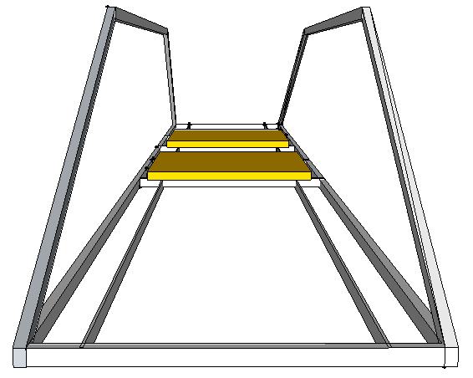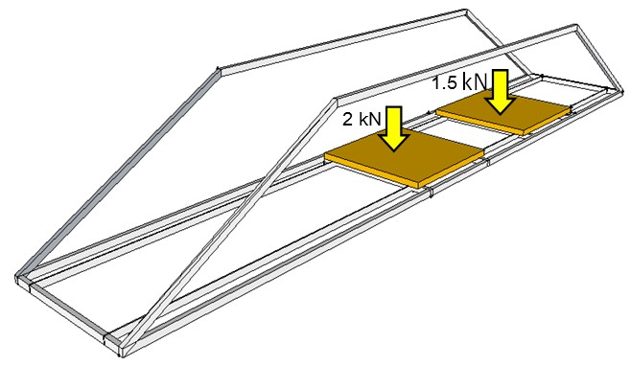



**Fig8.1** Data acquisition points for deflection (red arrows)

**Picture1.tif**

**Fig.8.2** Two deflection acquisition points for deck bridges

# 9. Examination

Bridge Examination is done by your referees. The examination is listed as follows.

* 1. Before the construction
* Size of bridge members
* Number of constructors
* Protective equipment (Helmet, gloves, goggle)

1. During the construction

* Construction time including repair works
* Drop of tools, fasteners, stepping into the river and so on
* Dangerous behavior

1. After the construction

* Clearance
* Bridge height from the pier top
* Deck support (through bridges or half through bridges)
* Weight

1. Before loading

* Displacement meters installation
* Loading order (100kgf to the span center, 100kgf to the 1/4 point, 50kgf to the span center, 50kgf to the quarter point and finally 50kgf to the span center )

1. After loading

* Deflections are recorded after 30 seconds from the completion of loading

1. Others

* Exceptions of above are explained by the committee.

1. End of Referring

* When all the examination finishes, the main referee gathers score sheets and submit them to the committee.

Referees can stop if they find a dangerous action or behavior during the competition.

# 10. Penalties

In case of a violation on the regulations, a penalty will be given. The penalty is to add construction time or bridge weight.

## 10.1 Limitation of a bridge member

The size of each bridge member is limited to $150mm×150mm×800mm$. If the size exceeds the limitation, an addition weight is given as a penalty. Followings are additional weight:

[Additional weight] = [Weight of the violated bridge member]*3+5(kg)

NOTE: In case weight of the bridge member is less than 1kg, the original weight of the member will be 1(kg).

## 10.2 Limitation of construction time

Construction must be completed in 30 minutes. If it exceeds 30 minutes, time measurement will be stopped; then, the construction will be continued outside of the construction field. In this case, construction time is regarded as 45 minutes. If number of constructors is three or less, it will be regarded as 6 constructors, and construction cost will be calculated.

## 10.3Assembly works outside of the staging yard

Constructors must do assembling works in the staging yard or on the pier. A bridge member, a tool and a fastener must not touch the ground except the staging yard although a penalty is not given.

## 10.4 Construction works outside of the construction site

Construction works must be done in the construction area. If a constructor works outside of the area, judges caution the constructor but not a penalty.

## 10.5 Clearance

The bridge clearance is regulated as “Clearance (mm) = pier height (mm) – 200mm”. It means that 200mm of the bridge lower parts can jut out from the pier top. The bridge part includes fasteners that are a bolt and a nut. If the clearance is violated, following weight penalty will be given.

|  |  |
| --- | --- |
| **Exceeding x (mm)** | **Additional weight (kg)** |
| 0<x≤10 | 2.5 |
| 10<x≤20 | 5 |
| 20<x≤30 | 7.5 |
| 30<x | 15 |



Fig.11.1 Clearance

## 10.6 Floor beams

Through bridges and half through bridges equip the deck support. Deck supports must be **RIGIDLY** supported by at least two floor beams in the area of loading. Floor beams hold the weight loads and carry it to the main structures. (See also **Fig.2.2**) If floor beams are not equipped in the loading area, 10kgf will be added to the own weight.

## 10.7 Space to install loading plate

If the bridge does not have enough space to carry loading plate stably, 5 kgf will be added to its own weight.

## 10.8 Bridge length

If the bridge length is shorter than 4000 mm, additional weight will be assigned according to:

$$Additional Weight=\frac{4000}{Bridge Length(mm)}×Current Bridge weight×0.05$$

## 10.9Gloves, Helmet, and Goggles

If any team member does not wear any of the protection equipment, i.e. gloves, helmet, or goggles, additional construction time of 10 second per equipment will be applied.

## 10.10 Others

The other issues are determined by the judges’ discussion.

## 10.11 Penalty table

|  |  |  |
| --- | --- | --- |
| **No.** | **Violation** | **Penalty** |
| 1 | To drop a fastener (bolt, nut, washer) (2.8) | 5 sec |
| 2 | To drop a fastener tool (spanner, wrench, ratchet) (2.8) | 10 sec |
| 3 | To drop a bridge member (2.8) | 20 sec |
| 4 | To drop a unit of connected bridge members.  A group of connected bridge members must be held by one or some constructors if the chain of bridge members is unstable. | 20 sec |
| 5 | To throw a bridge member, tool, nut or a bolt (5.4) | 20 sec |
| 6 | A constructor enters to the river  To touch or step the river boundary is regarded as an entry to the river. (2.8) | 5 sec |
| 7 | A constructor carries multi bridge members.(5.4) | Return back to the staging yard |
| 9 | A hinged member exists.(2.4) | +20kgf |
| 10 | A screwed or tapped member exists (2.7) | 30 sec |
| 11 | A bolt or nut preliminarily attached to the bridge member by welding exists and make them tight.(2.7) | 20 sec |
| 12 | Bridge width violates its regulation (2.1) | +10 kgf |
| 13 | A constructor conducts assembly works without self-support. (another constructor sustains his or her arm or body) (5.5) | Judges warn the constructor to stop it. |
| 14 | A bolt or nut is not separated from bridge members before the construction starts. (5.3) | 10 sec |
| 15 | A colored bolt or nut is tightened. (5.5) | 10 sec |
| 16 | A ready-component bolt or nut is not colored. (2.5) | 20 sec |
| 17 | Vehicle running space is not provided. (2.9) | +10 kgf |
| 18 | Floor beams are not equipped in the loading area. (2.3) | +15 kgf |
| 19 | Repair works after the timed construction (5.7) | Add (time for modification) * 1.5 |
| 20 | Gloves do not cover the whole fingers (5.3) | 10 sec per constructor |
| 21 | Size of bridge member violation (10.1) | Additional weight penalty given |
| 22 | Bridge clearance violation (10.5) | Additional weight penalty given |
| 23 | Not enough space to install loading plate (10.7) | +5kgf |
| 24 | Bridge length violation (10.8) | Additional weight penalty given |
| 26 | A constructor does not wearing gloves, helmets, or goggles (10.9) | 10 sec per equipment |